Name

Mathematics Stage 5 Paths
Congruence

Book 1 |  | Version: 261007  Feedback:  https://MrDingMaths.com
Contents
Syllabus Content 2
Learning Intention 3

Syllabus Content
MA5-GEO-P-01 establishes conditions for congruent triangles and similar triangles and solves problems relating to properties of similar figures and plane shapes
Identify and explain congruence
- Identify figures as congruent figures if translations, reflections and rotations can move one figure exactly on top of another
- Match the sides and angles of 2 congruent polygons
- Indicate 2 polygons are congruent using the symbol $(≡)$ and name the vertices in matching order
- Determine that having equal radii is the condition for 2 circles to be congruent
Develop and use the conditions for congruent triangles
- Establish the 4 congruence tests for triangles (SSS, SAS, AAS and RHS)
- Use the congruence tests to identify a pair of congruent triangles from a selection of 2 or more triangles

Congruence

- Congruent Shapes
- Congruent shapes are identical - they have the same angles, side lengths and area.
- If you translate (slide), reflect (flip), or rotate (spin) a shape,
then the image is congruent to the original.
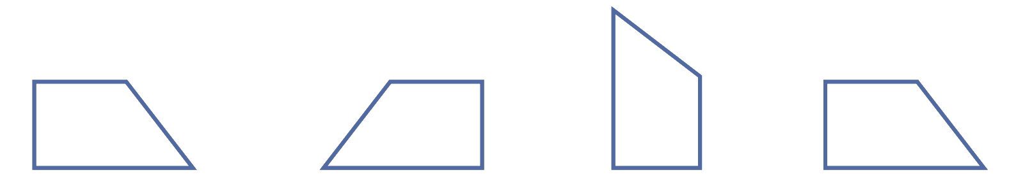

- The corresponding (or matching) vertices, angles, and sides of two congruent shapes are equal.

- Example Identify corresponding sides and angles in congruent figures
Worked Example | Your Turn
Identify the matching vertices.  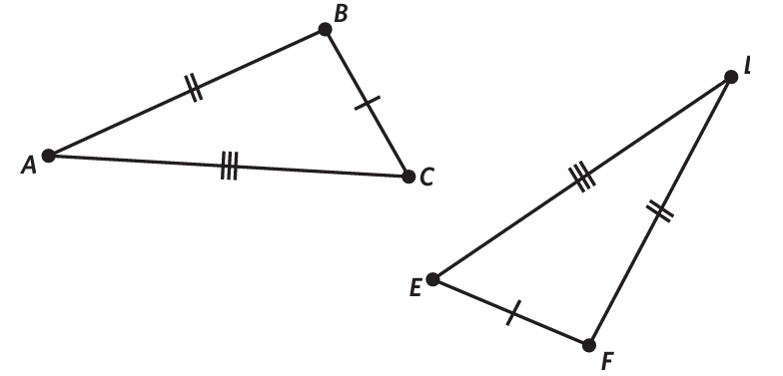 | 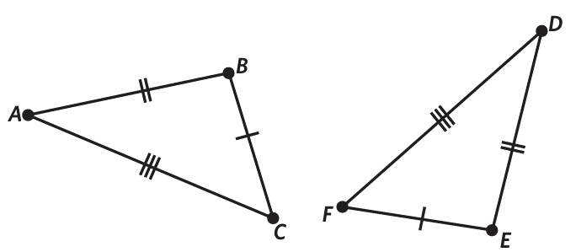  Identify the matching vertices.

- Key Ideas
- If two figures are ……………, then they are exactly identical.
- If you ………………, …………………, or ………………… a shape,
then the image is congruent to the original.
- If two figures are congruent, ………………… sides and angles are equal.

Foundation
- Identify the matching vertices.
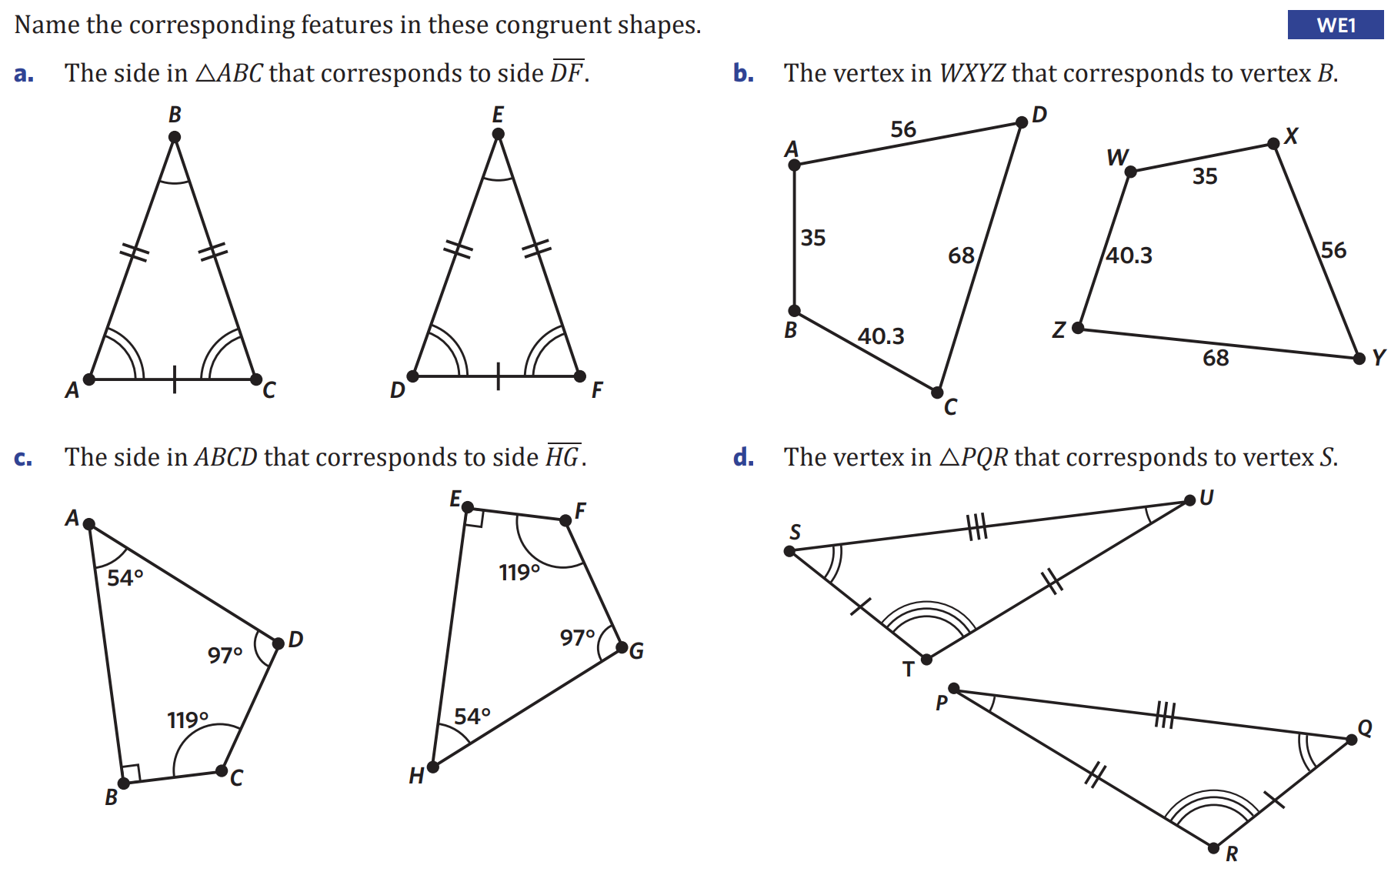  A – D, B – E, C – F | S – Q, U – P, T – R
A – H, D – G, C – F, B – E | A – X, D – Y, C – Z, B – W

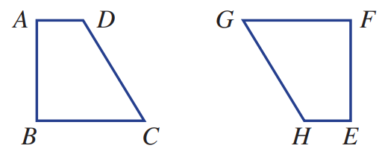
- These two quadrilaterals are congruent.
Name the feature in EFGH that corresponds to these features in ABCD.

- A  E | - D  H | - AD  HE
- CD  HG | - ∠C  ∠G | - ∠A  ∠E

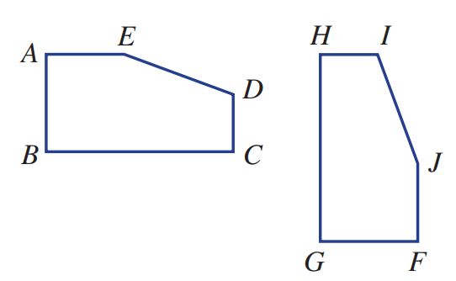
- These two pentagons are congruent. Name the object in pentagon FGHIJ that corresponds to these objects in pentagon ABCDE .

- A  F | - D  I | - AE  FJ
- CD  HI | - ∠C  ∠H | - ∠E  ∠J

- In this diagram △ABC has been translated to give the image triangle △DEF .
  - Is △DEF congruent to △ABC?
Yes, rotations are isometric
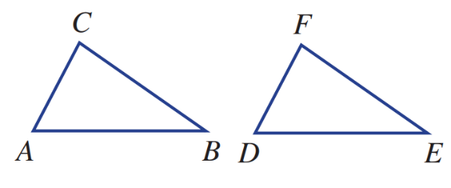
  - Name the vertex on △DEF that corresponds to:
    - A ……… ii B ……… iii C ………
D E F
  - Name the side on △DEF that corresponds to:
    - AB ……… ii BC ……… iii AC ………
DE EF DF
  - Name the angle in △DEF that corresponds to:
    - ∠B ……… ii ∠C ……… iii ∠A ………
∠E ∠F ∠D

- In this diagram △ABC has been reflected to give the image triangle △DEF .
  - Is △DEF congruent to △ABC? ……………………………………
Yes, reflections are isometric
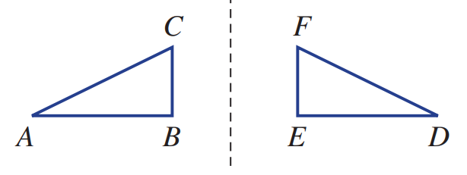
  - Name the vertex on △DEF that corresponds to:
    - A ……… ii B ……… iii C ………
D E F
  - Name the side on △DEF that corresponds to:
    - AB ……… ii BC ……… iii AC ………
DE EF DF
  - Name the angle in △DEF that corresponds to:
    - ∠B ……… ii ∠C ……… iii ∠A ………
∠E ∠F ∠D

- In this diagram △ABC has been rotated to give the image triangle △DEF .
  - Is △DEF congruent to △ABC? ……………………………………
Yes, rotations are isometric
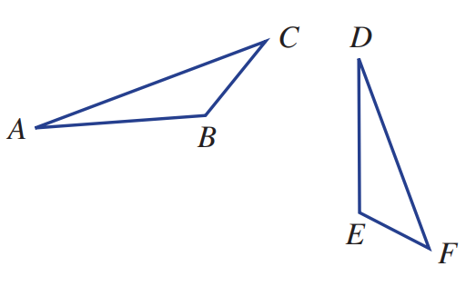
  - Name the vertex on △DEF that corresponds to:
    - A ……… ii B ……… iii C ………
D E F
  - Name the side on △DEF that corresponds to:
    - AB ……… ii BC ……… iii AC ………
DE EF DF
  - Name the angle in △DEF that corresponds to:
    - ∠B ……… ii ∠C ……… iii ∠A ………
∠E ∠F ∠D

Congruence Statements

- Congruence Statements
- The symbol ≡ indicates congruence.
- Identify the corresponding vertices.
- Write vertices in corresponding order.

- Example Write a congruence statement
Write a congruence statement
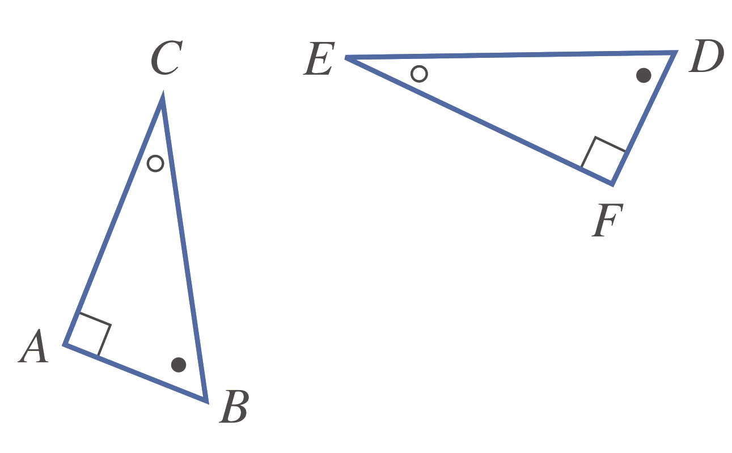

1. | 2. $ΔABC≡ΔFDE$

- Guided Practice
Write a congruence statement for these congruent shapes.
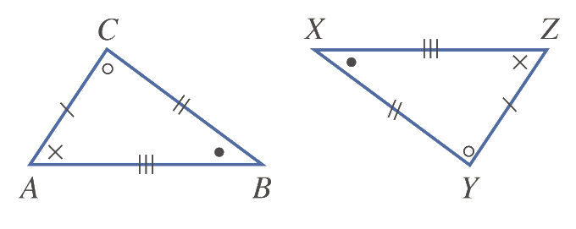  $Δ$ ……… $≡Δ$ ………  $$ΔABC≡ΔZXY$$ | 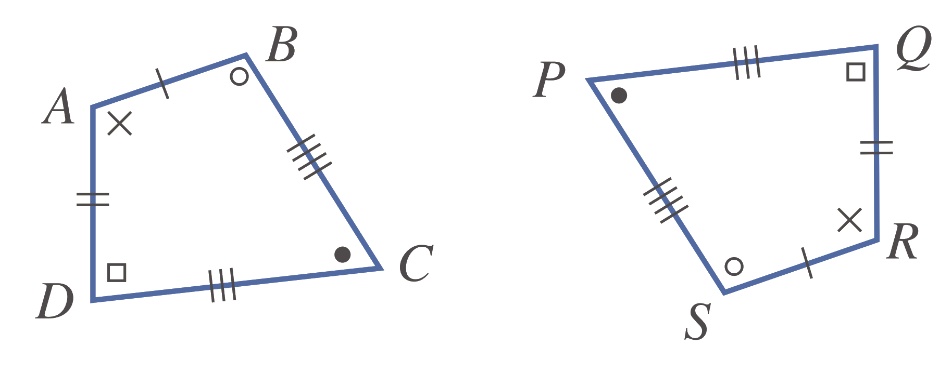  $$ABCD≡RSPQ$$

- Key Ideas
- If ABC is congruent to triangle STU then we write ΔABC …… ΔSTU.
- When writing congruent statements, the vertices must be in ………………… order.

Foundation
- Write a congruence statement for these shapes.
Remember that the matching vertices should be in the same order.
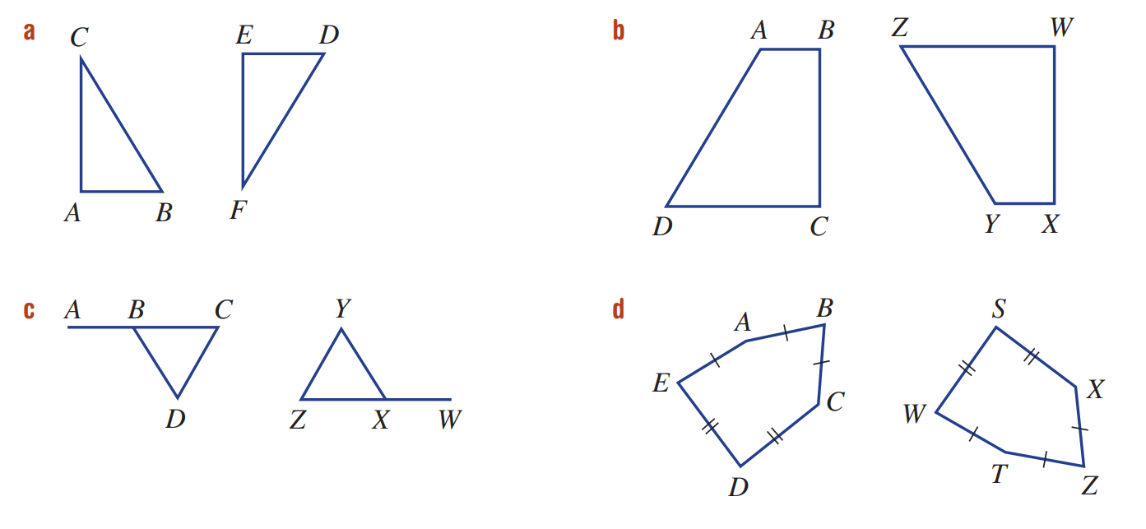  $Δ$ ……… $≡Δ$ ………  $$ΔABC≡ΔEDF$$ | $$ABCD≡YXWZ$$
$$ABCD≡WXZY$$ | $$ABCDE≡TZXSW$$
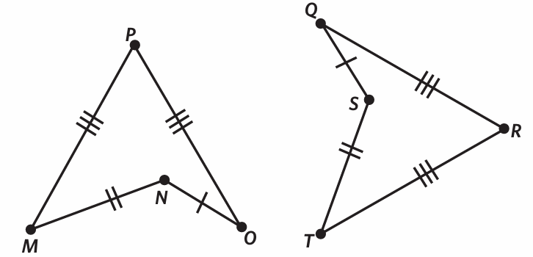  $$MNOP≡TSQR$$ | 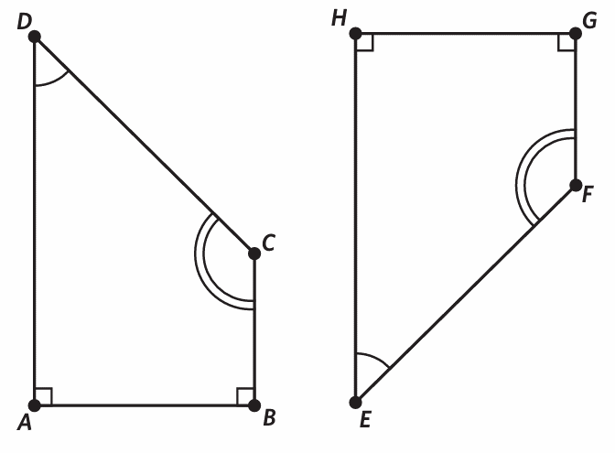  $$ABCD≡HGFE$$

- These triangles are congruent.
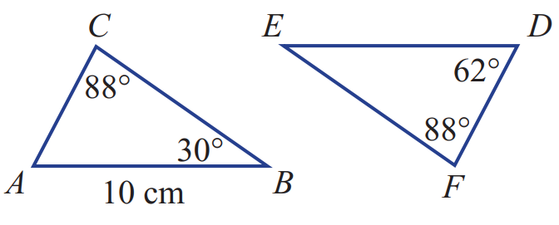
  - Write a congruence statement:
$Δ$ ……… $≡Δ$ ………
$$ΔABC≡ΔDEF$$
  - Which side on ΔDEF corresponds to side AB?
ED
  - What is the length AB? ………………
10
  - What is the length DE? ………………
10
  - Which angle on ΔABC corresponds to ∠E?
$$∠B$$
  - What is the size of ∠B? ………………
62°
  - What is the size of ∠E? ………………
30°

Development
- These pairs of figures are congruent. Find the value of the pronumeral in each case.
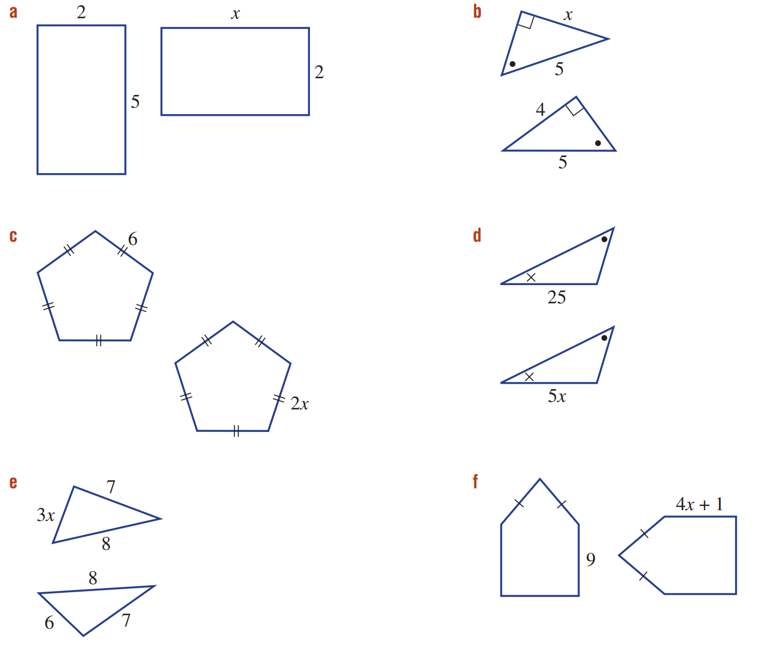  5 | 4 | 3
5 | 2 | 2

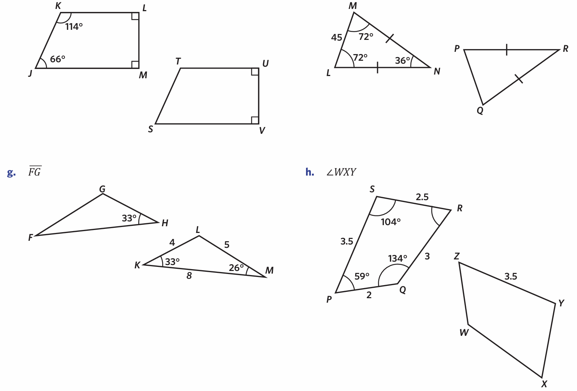
- For each shape, write the congruence statement then find the size of the missing angle or side.
- ……… $≡$ ………  $∠TSV=$ ………  JKLM $≡$ STUV, $∠TSV=66°$ | - $Δ$ ……… $≡Δ$ ………  $∠PRQ=$ ………  LMN $≡$ QPR, $∠PRQ=36°$
- $Δ$ ……… $≡Δ$ ………  $FG=$ ………  FGH $≡$ MLN, FG = 5 | - ……… $≡$ ………  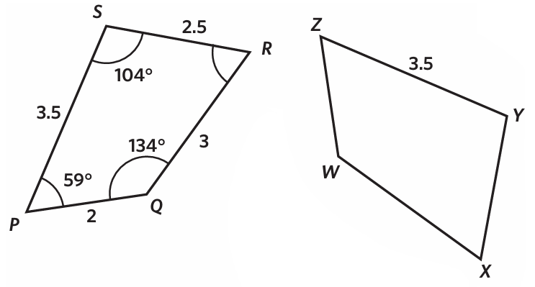  $∠WZY=$ ………  PQRS $≡$ ZWXY, $∠WXY=63°$

- Find the value of the pronumerals in these diagrams that include congruent triangles.
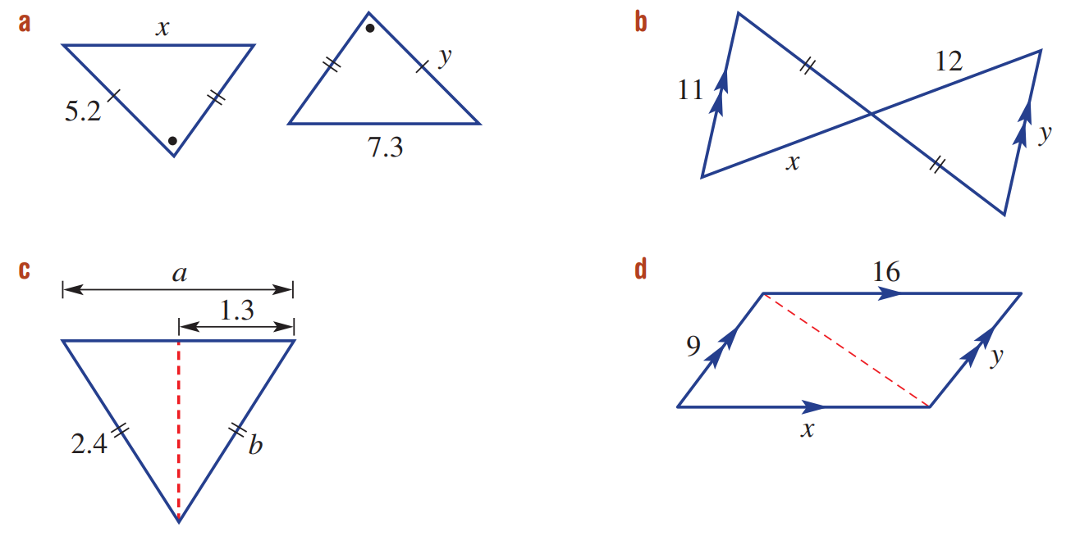  $$x=7.3, y=5.2$$ | $$x=12, y=11$$
$$a=2.6, b=2.4$$ | $$x=16, y=9$$

Conditions for Congruent Triangles

- Congruent Triangle Tests
SSS  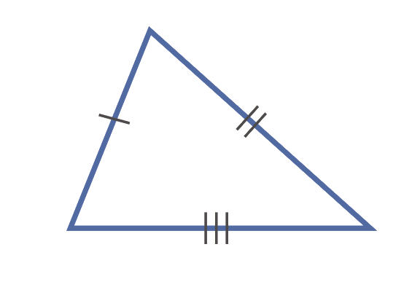  Three pairs of corresponding sides. | SAS  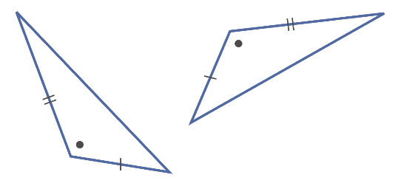  Two pairs of corresponding sides and the included angle equal.
AAS  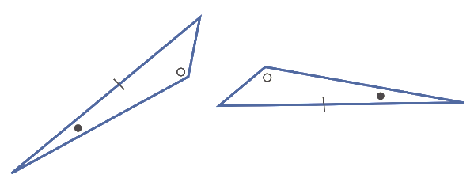  Two pairs of corresponding angles and one pair of corresponding sides equal. | RHS  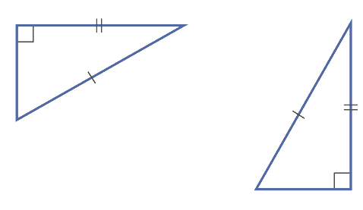  For a right-angled triangle, the hypotenuse and another corresponding side equal.

- Identify congruent triangles using the four congruence tests
Which of the tests (SSS, SAS, AAS or RHS) prove the congruence of these pairs of triangles?
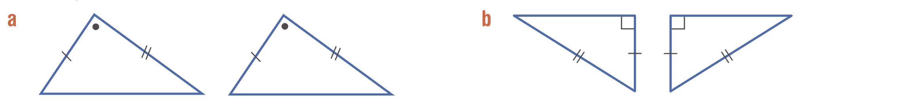

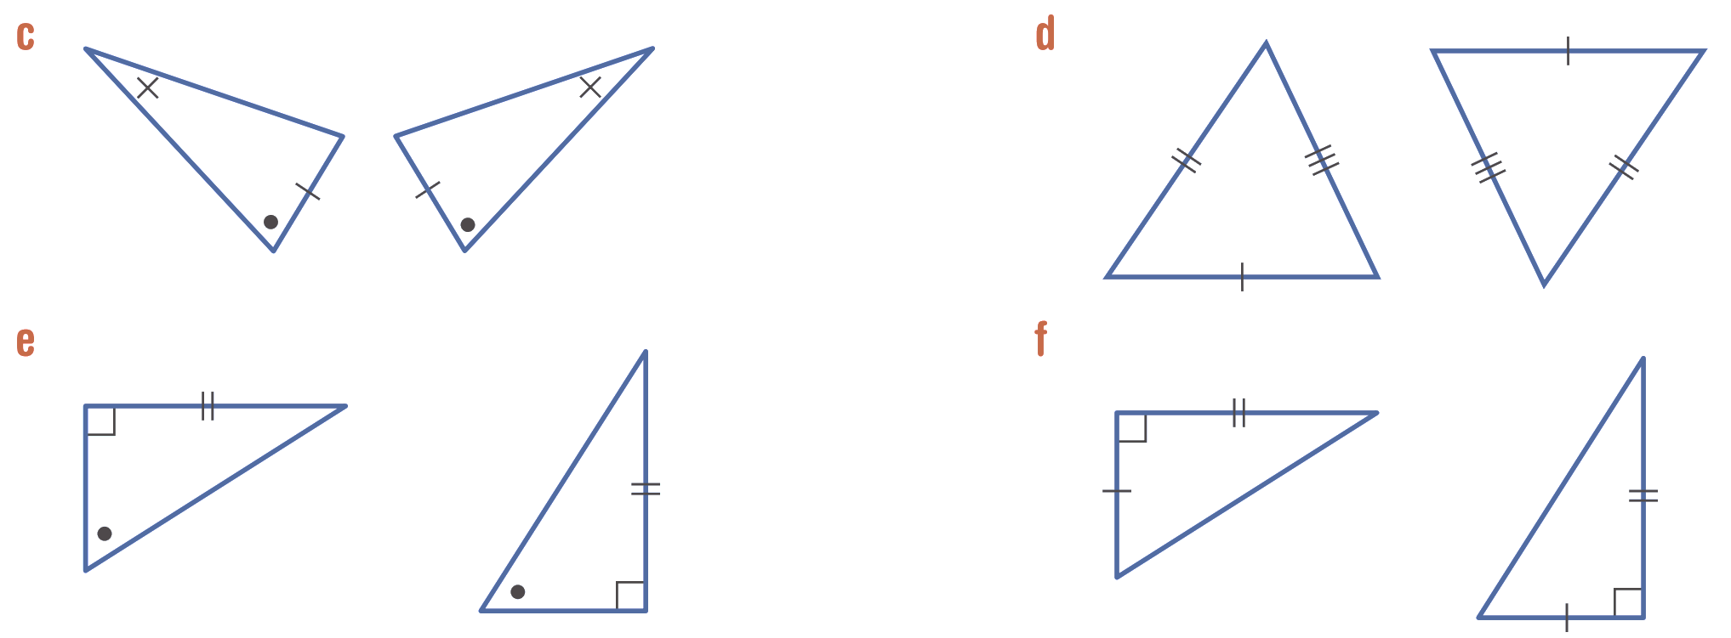

Foundation
- Pick the congruence test (SSS, SAS, AAS or RHS) for each pair of congruent triangles.
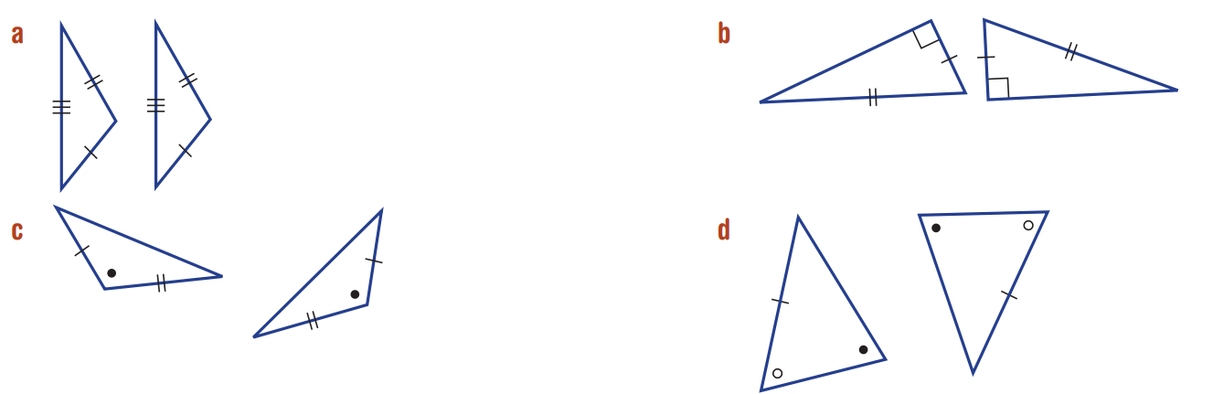  SSS | RHS | SAS
  - SSS | - SAS
  - AAS | - RHS
  - SSS | - SAS
  - AAS | - RHS
  - SSS | - SAS
  - AAS | - RHS
AAS | 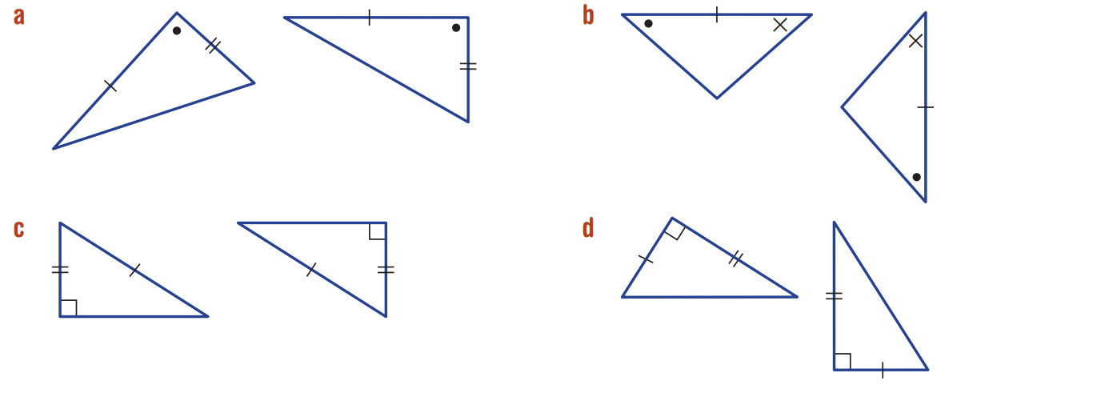  SAS | AAS
  - SSS | - SAS
  - AAS | - RHS
  - SSS | - SAS
  - AAS | - RHS
  - SSS | - SAS
  - AAS | - RHS
RHS | SAS | 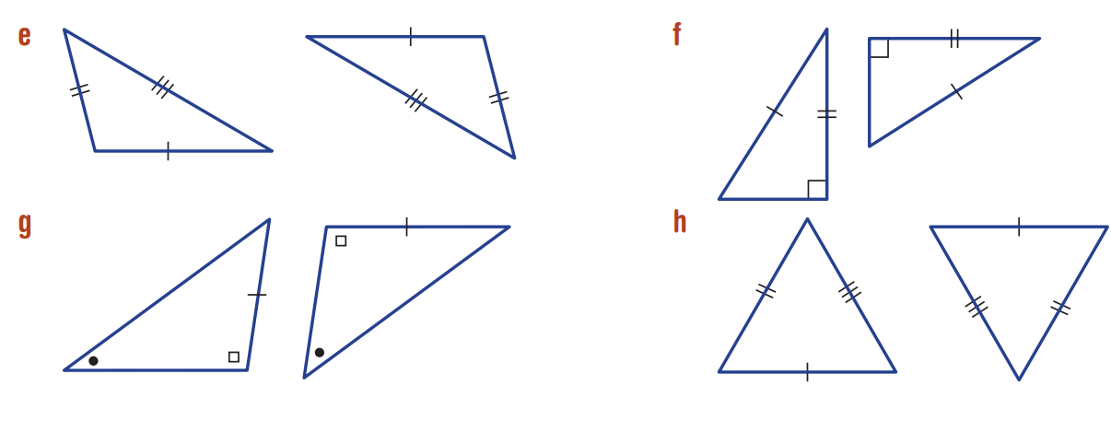  SSS
  - SSS | - SAS
  - AAS | - RHS
  - SSS | - SAS
  - AAS | - RHS
  - SSS | - SAS
  - AAS | - RHS
RHS | AAS | SSS
  - SSS | - SAS
  - AAS | - RHS
  - SSS | - SAS
  - AAS | - RHS
  - SSS | - SAS
  - AAS | - RHS

- Which test (SSS, SAS, AAS or RHS) proves the congruence of these triangles?
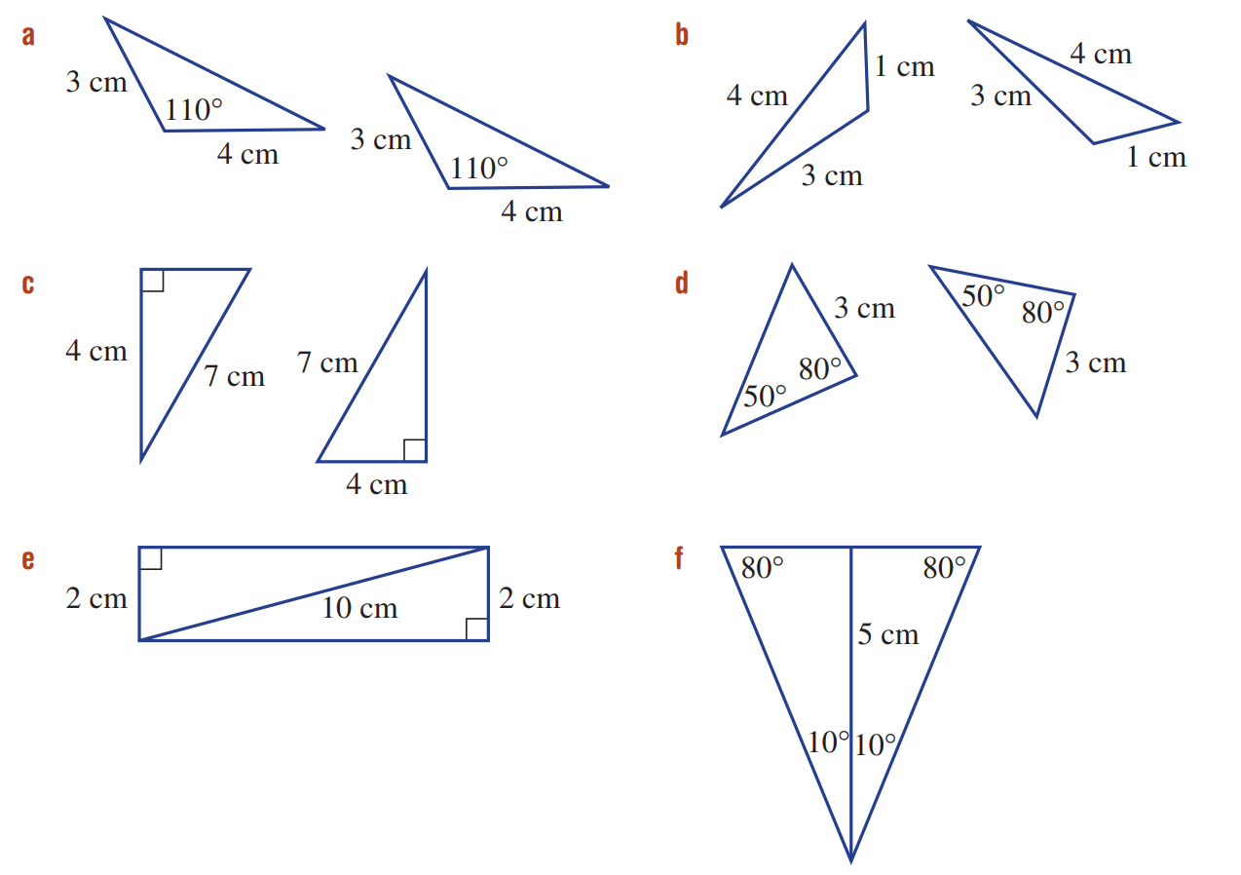  SAS | SSS
RHS | AAS
RHS | AAS

- Decide if these pairs of triangles are congruent.
If they are, write the test (SSS, SAS, AAS or RHS).
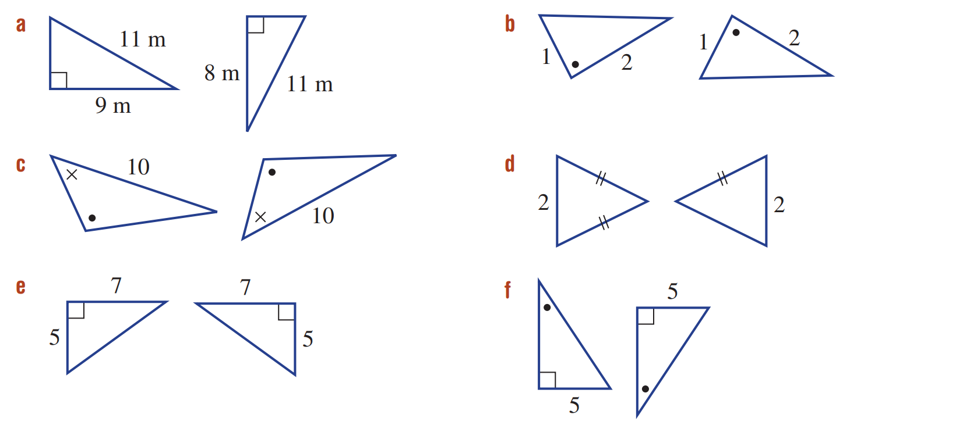  SAS | Not congruent
AAS | Not congruent
SAS | AAS

Development
- For each set of three triangles, choose the two that are congruent. Choose the appropriate test (SSS, SAS, AAS or RHS) and write a congruence statement (e.g. ΔABC ≡ ΔFGH).
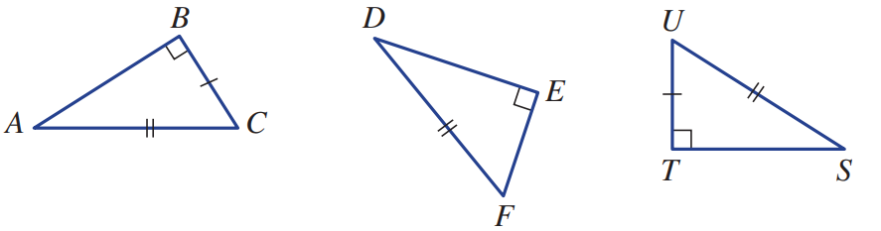

$$ΔABC≡ΔSTU (RHS)$$
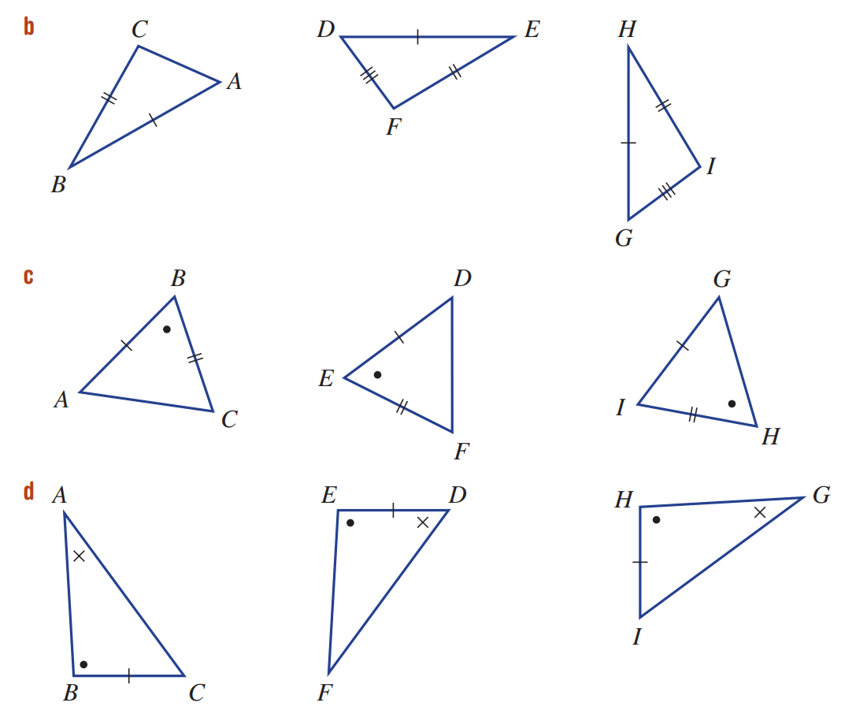

$$ΔDEF≡ΔGHI (SSS)$$

$$ΔABC≡ΔDEF (SAS)$$

$$ΔABC≡ΔGHI (AAS)$$

- Add 1 piece of information to each diagram to make the two triangles congruent, and state the congruence test you are using.
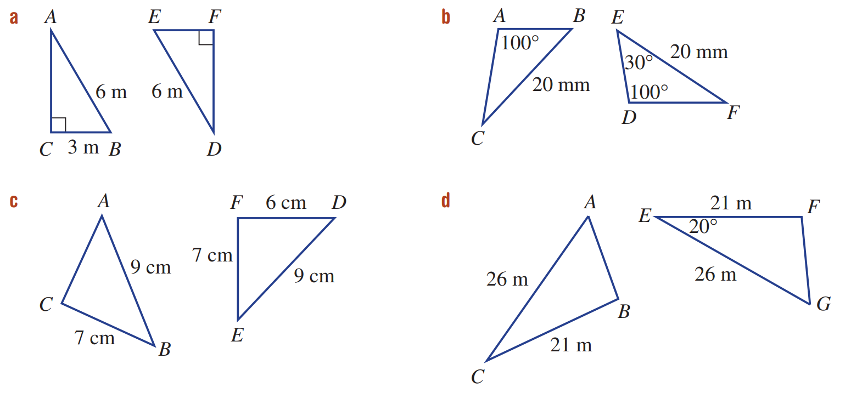  EF = 3 m, RHS | $∠ABC=30°$, AAS
AC = 6 cm, SSS | $∠ACB=20°$, SAS

Mastery
- Decide if each pair of triangles is congruent.
You first need to use the angle sum of a triangle to help calculate some of the angles.
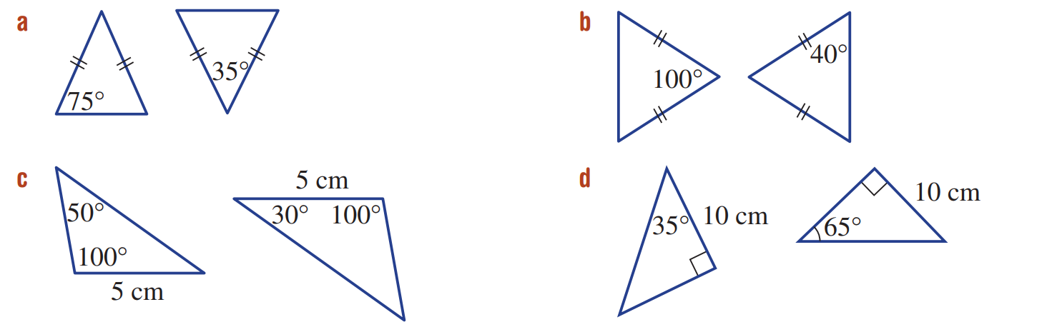  yes | no
yes | no

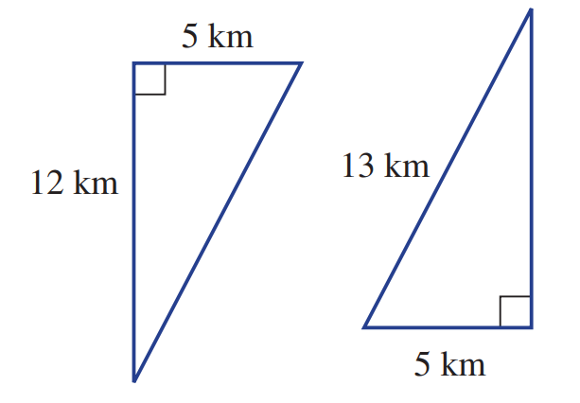
- Two adjoining triangular areas of land have the dimensions shown.
Use Pythagoras’ theorem to help decide if the two areas of land are congruent.

yes
- Consider this diagram including two triangles.
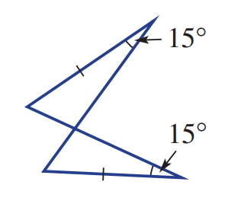
  - Explain why there are two pairs of equal matching angles.

There is a pair of equal 15° angles (given)
And there is a pair of equal vertically opposite angles
  - Give the reason (SSS, SAS, AAS or RHS ) why there are two congruent triangles.
AAS

- ABCD is a parallelogram.
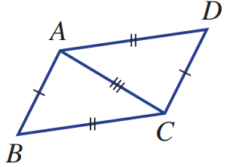
  - Give the reason why ΔABC ≡ ΔCDA.
SSS
  - What does this say about ∠B and ∠D?

They are the same as corresponding angles in congruent triangles are equal.
This is also a property of a parallelogram (opposite angles equal)
- Determine a test that could be used to prove these triangles are congruent.
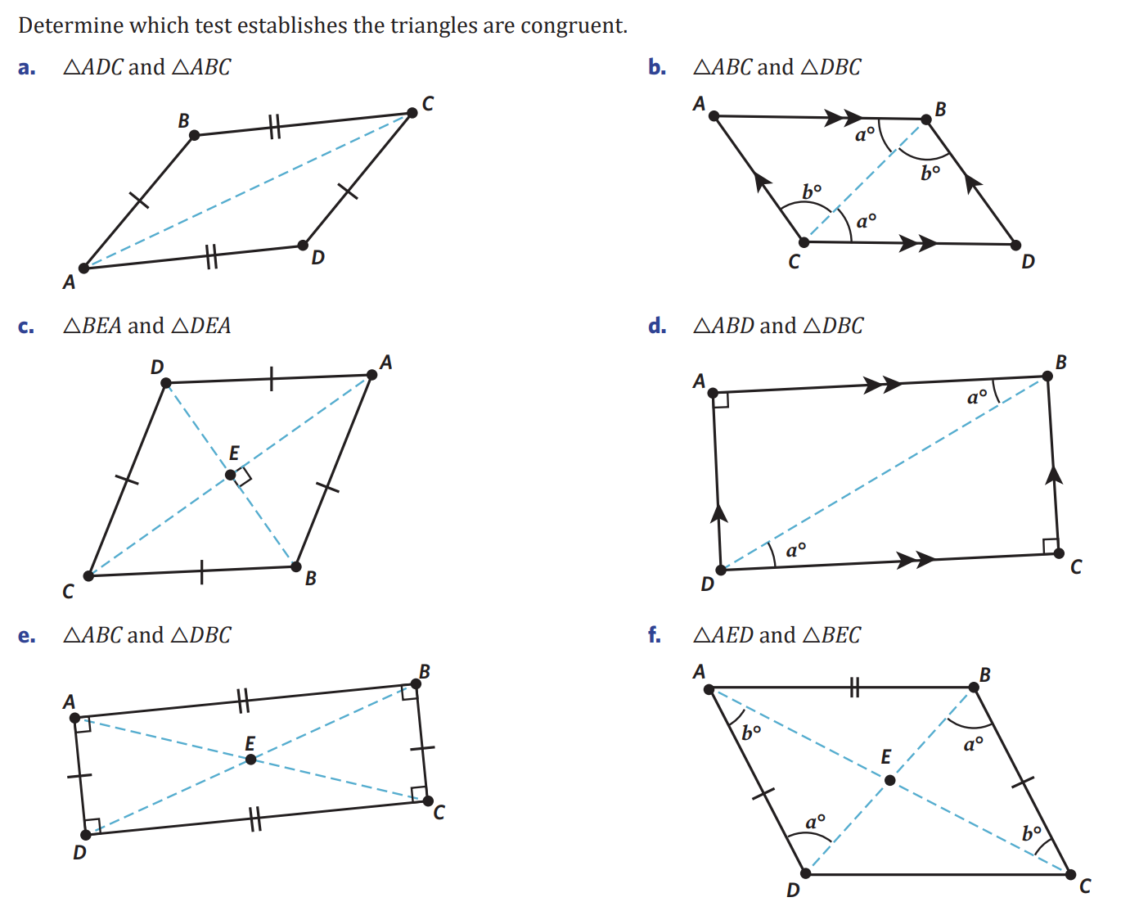  SSS | AAS
RHS | AAS
SSS | AAS
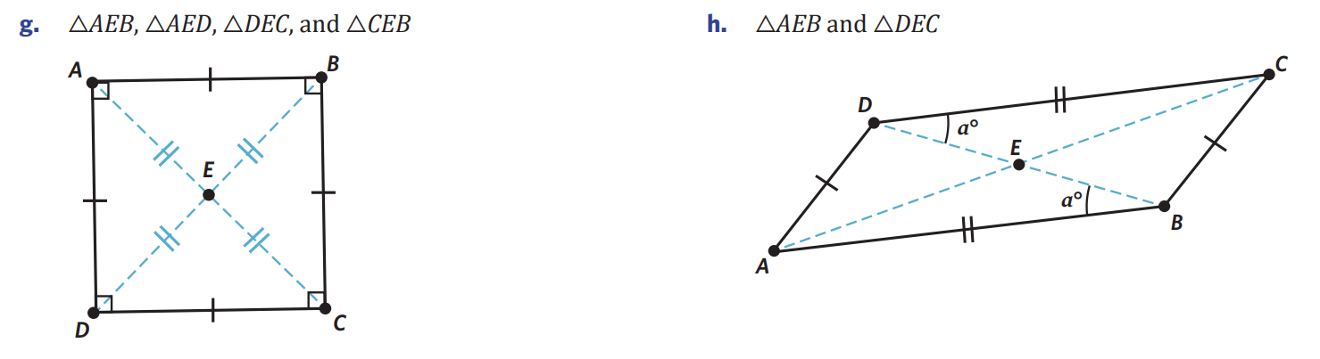  SSS | AAS

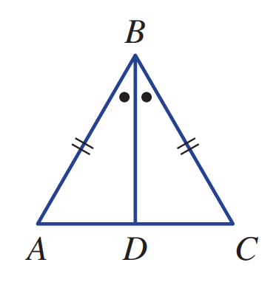
- Consider this diagram.

  - Explain why there are two pairs of matching sides of equal length for the two triangles $Δ$ABD and $Δ$CBD
AB = BC (given)
BD is a common side
  - Give the reason (SSS, SAS, AAS or RHS) why there are two congruent triangles.
SAS
  - Write a congruence statement.
$$ΔABD≡ ΔCBD (SAS)$$
  - Explain why AC is perpendicular (90°) to DB.
$∠ADB=∠CDB$(corresponding sides on congruent triangles)
But $∠ADB+∠CDB=180°$ (angles on a straight line)
Since the two angles are equal and sum to 180, each angle must be 90°.
So AC is perpendicular to DB
- In this diagram O is the centre of the circle and ∠AOB = ∠COB.
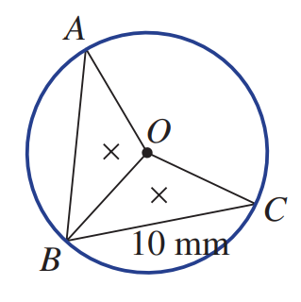
  - Give the reason why △AOB ≡ △COB

(OA, OB, OC) are all radii of a circle and equal.
SAS
  - Hence state the length of AB.

10 mm (corresponding sides of congruent triangles equal)
- An isosceles triangle is cut as shown, using the midpoint of AB.
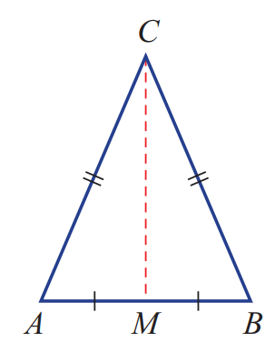
  - Name the two triangles formed.
$$ΔACM, ΔBCM$$
  - Will the two triangles be congruent? Give reasons.

Yes, by SSS

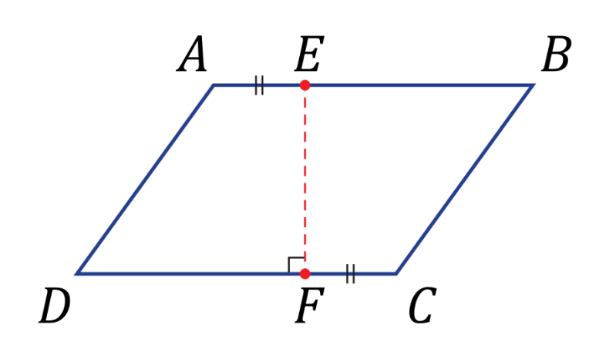
- If this parallelogram is cut as shown, explain why the two pieces are congruent.
(hint: what are the properties of a parallelogram?)
$AE=FC$ (given)
$AD=BC$ (opposite sides of parallelogram equal)
$EB=FD$ (opposite sides of parallelogram equal)
EF is common
So, all corresponding sides are equal

$∠ADF=∠CBE$ (opposite angles of parallelogram equal)
$∠DAE=∠BCF$ (opposite angles of parallelogram equal)
$∠EFC=90°$ (angles on a straight line sum to 180)
$∠FEA=∠EFD=90°$ (co-interior angles between parallel lines sum to 180)
$∠FEB=∠EFC=90°$ (co-interior angles between parallel lines sum to 180)
All four sides equal and all angles equal, therefore congruent.

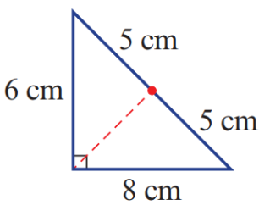
- If this triangle is cut as shown, determine whether the two triangles will be congruent. Explain.

No, let the red line have length $x$
the sides of one triangle are 5, $x$, 6 and the other is 5, $x$, 8
So they cannot be congruent as the sides are not equal.

